**Experiment No : 1**

**Aim:**

TO CREATE SIMPLE CLOUD SOFTWARE APPLICATION AND PROVIDE IT AS A SERVICE USING ANY CLOUD SERVICE PROVIDER TO DEMONSTRATE SOFTWARE AS A SERVICE (SAAS).

**PROCEDURE:**

**Login to** [**https://www.zoho.com**](https://www.zoho.com)

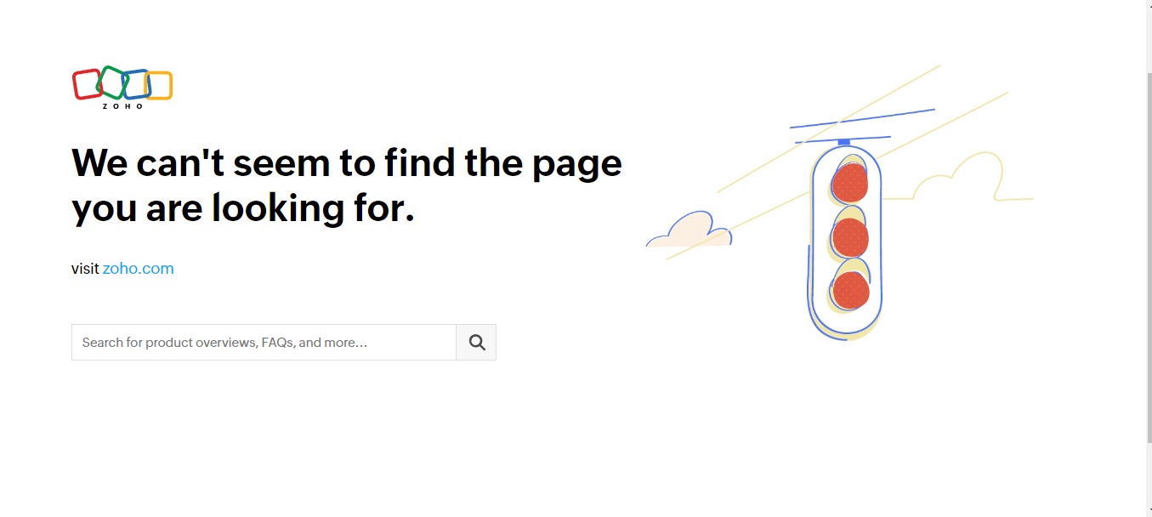

**Select Forms from the page.**

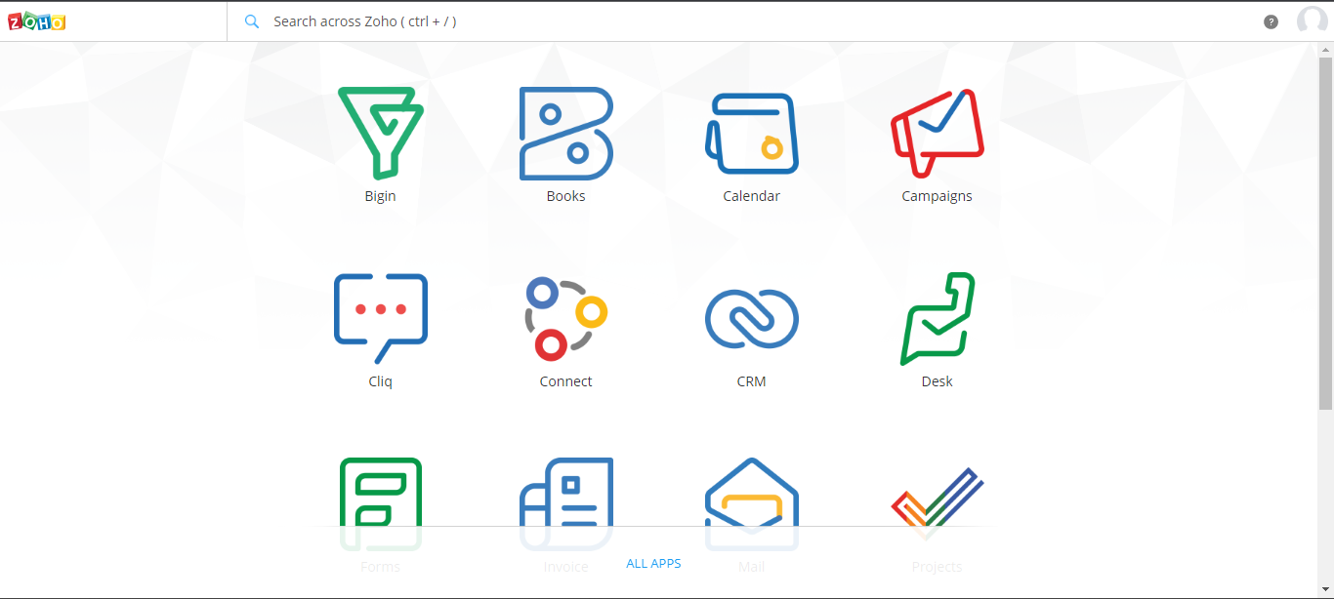

**Enter the Title of Form:**

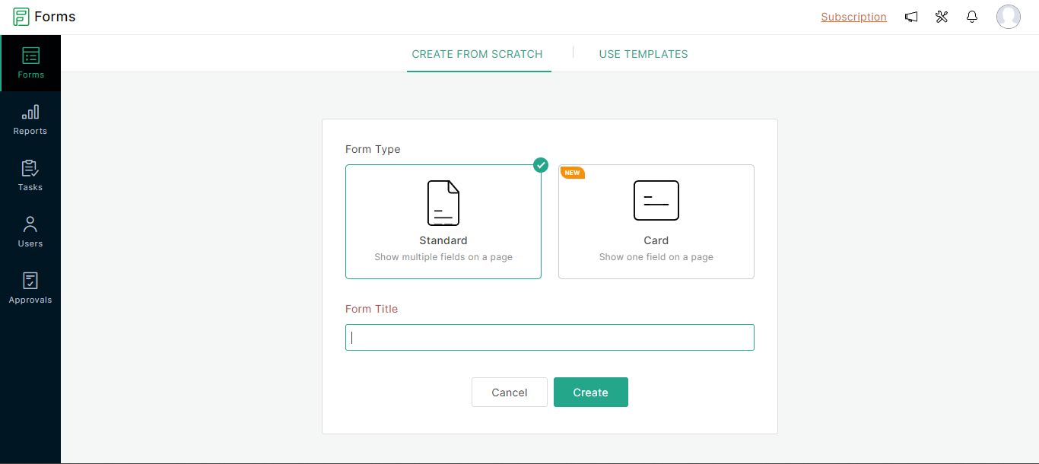

**Go to the Edit option and we can edit the interface likely we want:**

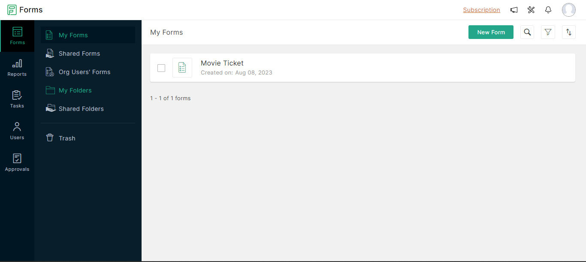

**Interface for the form:**

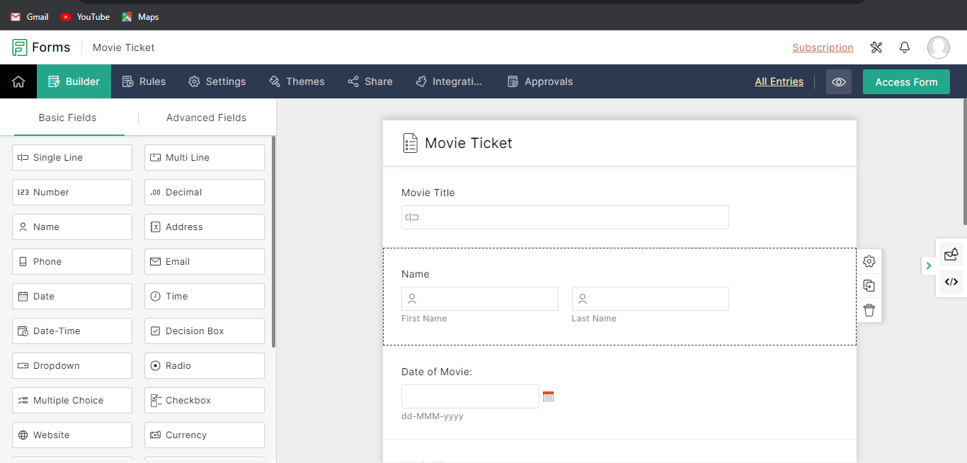

**Over View of the Form:**

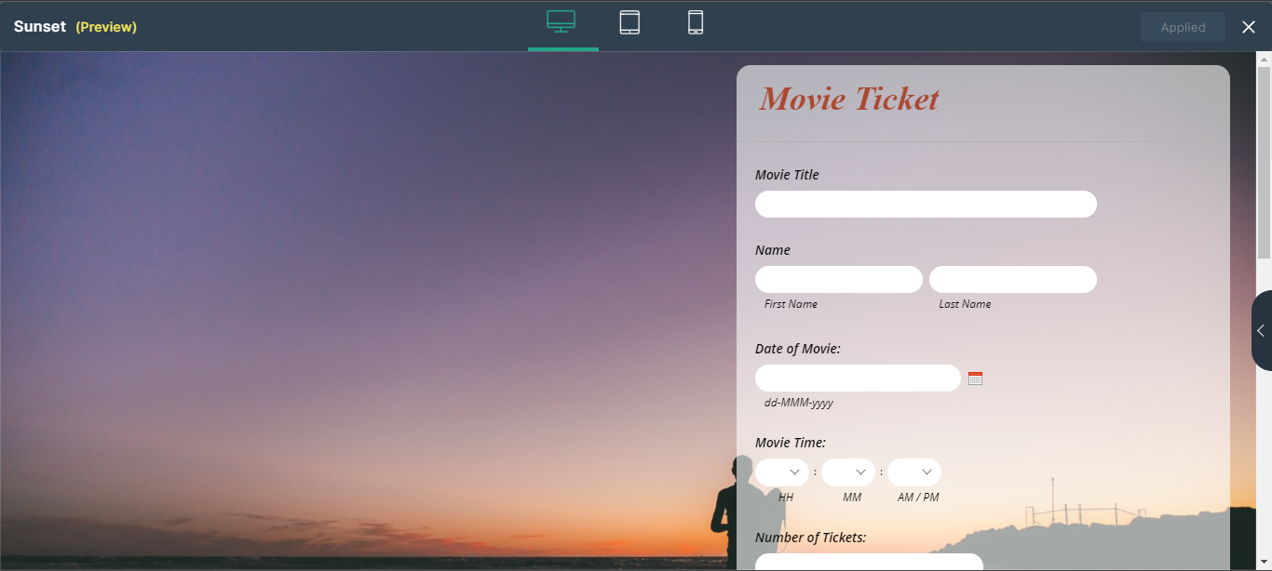

**Responses :**

